Goal: Search parameters in NNF & PNF such that the following constraints are met

1. Relative amp of Ptot > 0.25

2. max(Ptot) is minimized s.t Kd is maximized

~~3. BMAL (At) average level matches SNF model~~

4. Relative amp of BMAL ~ 0.2

~~5. Period of Ptot matches SNF~~

6. max(Rev) < 10, max(Ror)<5

SNF 1L3 1L8

Add Ka = 0 (SNF 0LN superimposed)

Dashlines

1MN model

1. SNF 1M8

Kd=1, Vmax=5, Km=5.5, KA=20, AT=20, alpha=50

period = 27

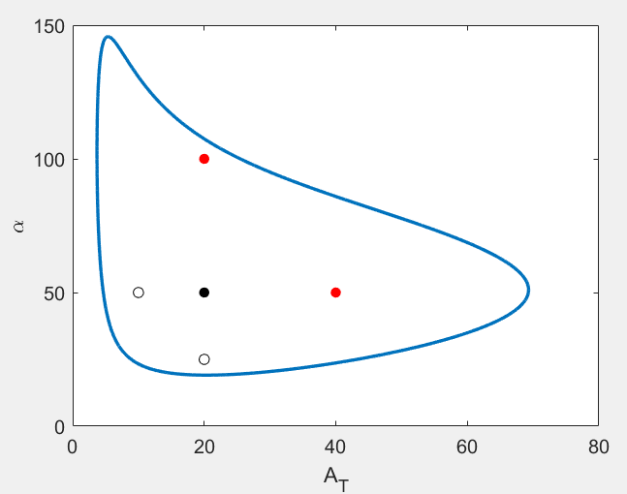 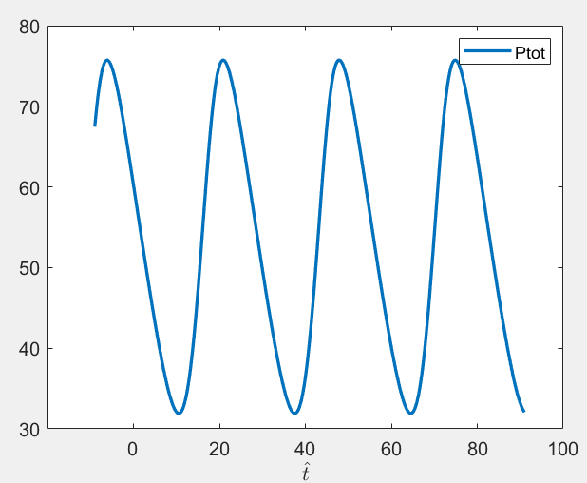

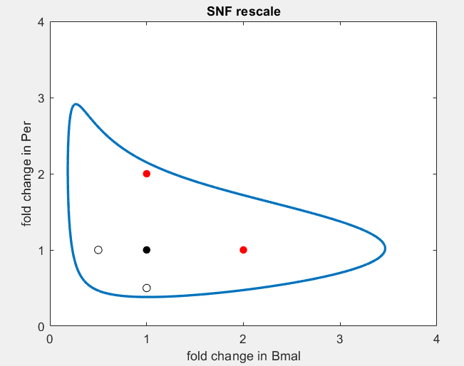

2. NNF

delta = 0.13, Amax=48, Vmax=25

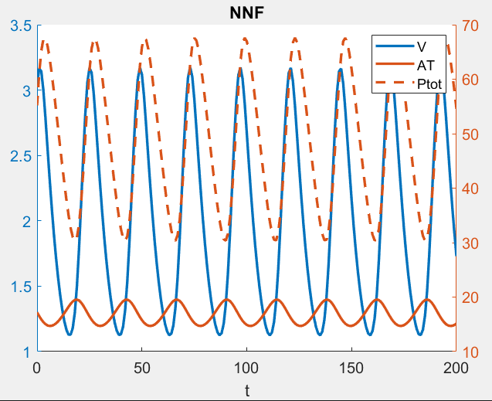

|  |  |
| --- | --- |
| constraint | Simulation result |
| BMAL amp ~ 0.2 | 0.2 |
| BMAL max ~ 20 | 20 |
| Minimize max(Ptot) | 67 (SNF is ~75) |
| Ptot amp > 0.25 | .25 |
| Ptot Period ~ 27 | 24 |

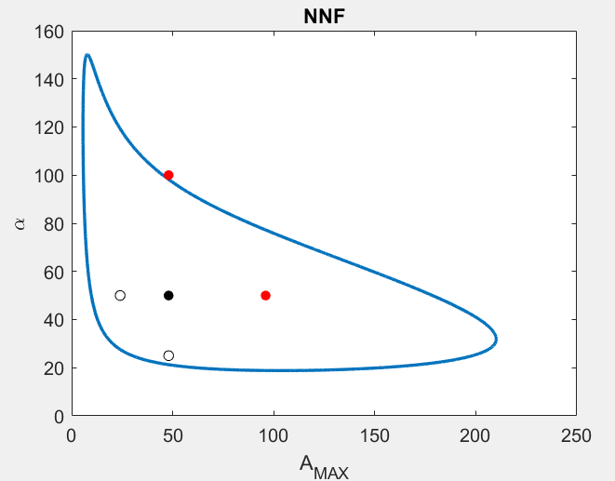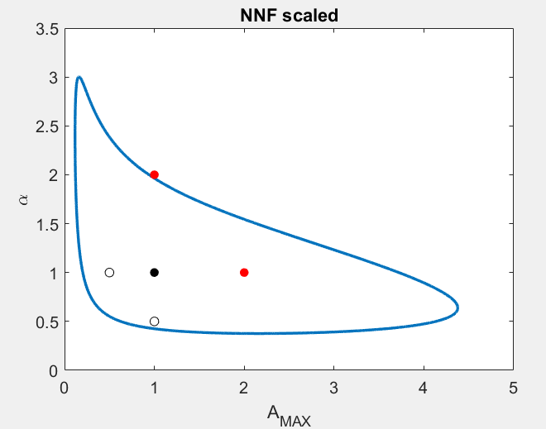

*black dot* corresponds to Amax=48, alpha=50 (keep alpha, Km, Ka the same as SNF)

3. PNF

delta = 0.1, Amax=92, Rmax=3

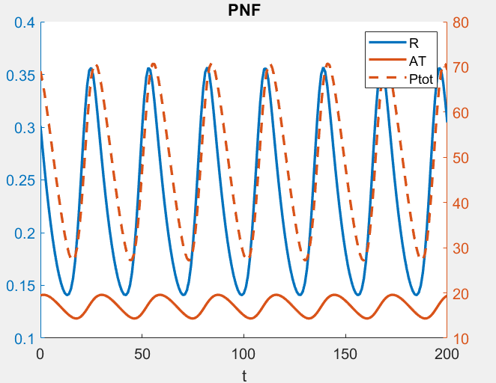

|  |  |
| --- | --- |
| constraint | Simulation result |
| BMAL amp ~ 0.2 | 0.2 |
| BMAL max ~ 20 | 20 |
| Minimize max(Ptot) | 70 (SNF is ~75) |
| Ptot amp > 0.25 | .4 |
| Ptot Period ~ 27 | 29 |

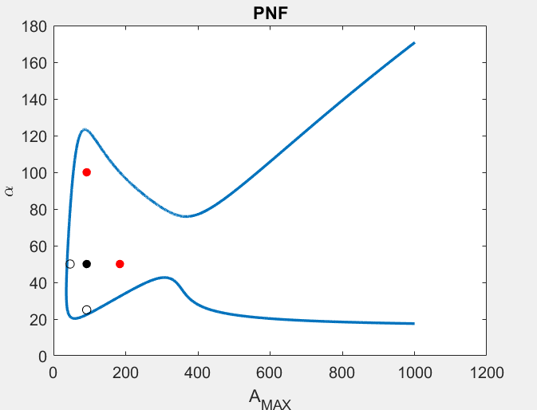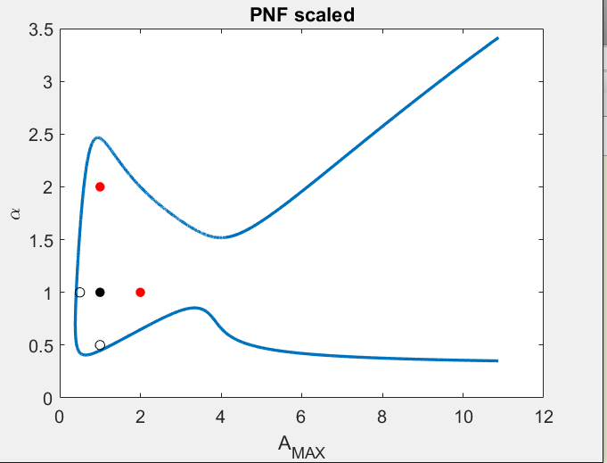

*black dot* corresponds to Amax=92, alpha=50 (keep alpha, Km, Ka the same as SNF)

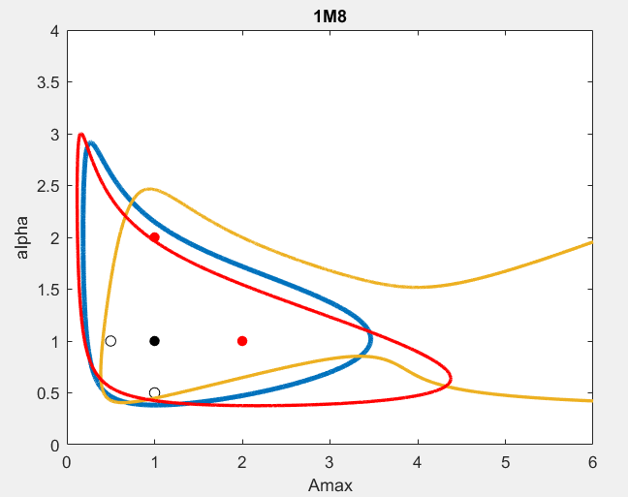

Period tracing based on these sets of parameters.

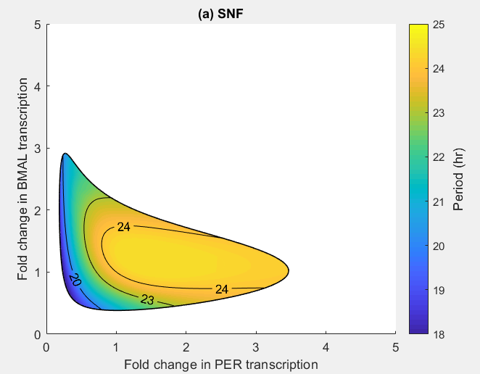

Kd=1, Vmax=5, Km=5.5, KA=20, AT=20, alpha=50

(1,1) has dimensional period = 24

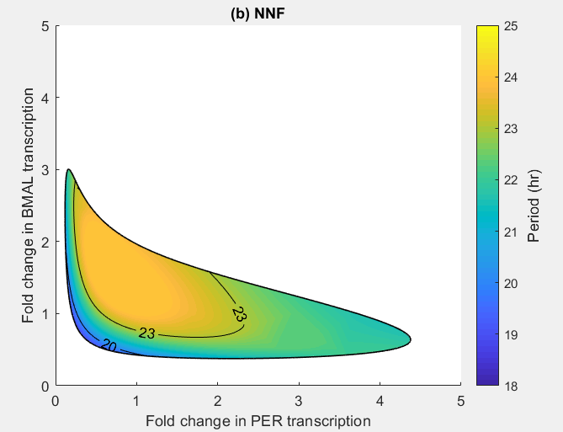

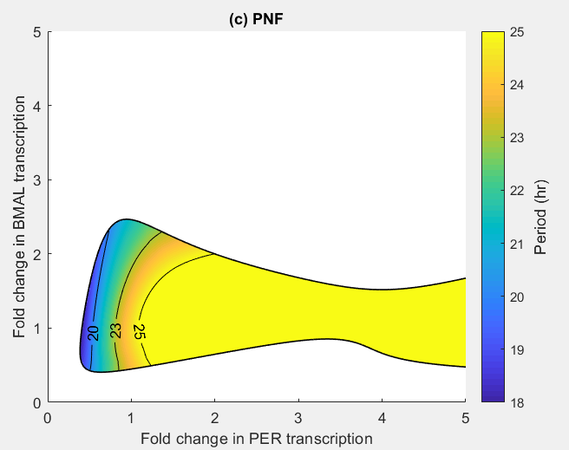

10/25 Parameter search with new constraints

1. Relative amp of Ptot > 0.25

2. max(Ptot) is minimized s.t Kd is maximized

3. Relative amp of BMAL ~ 0.2

4. max(Rev) < 10, max(Ror)<5

The parameters in the core negative loop are not kept the same as SNF

1. SNF

Kd=1, Vmax=5, Km=5.5, KA=20, AT=20, alpha=50

max(Ptot)~75

2. NNF

1) delta = 2.4, Amax =4.4, Vmax = 5.8, Ka=6.8, alpha= 32, Km= 1, beta= 3.4

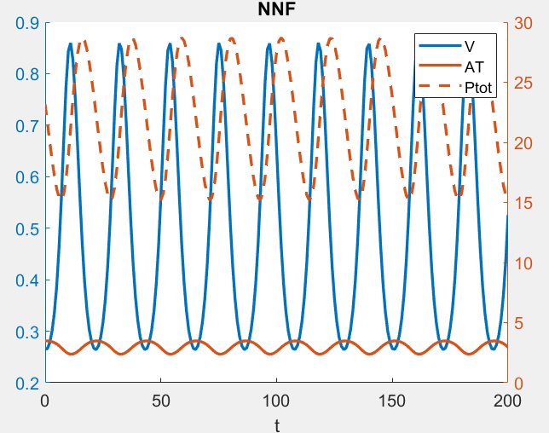

max(Ptot)~30

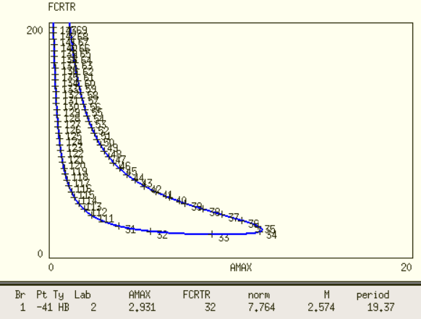

5-point criteria not met

2) delta = 1.3, Amax =7, Vmax = 9, Ka=12, alpha= 49, Km= 1.4, beta= 3.1

[1.3 7 9 12 49 1.4 3.1]

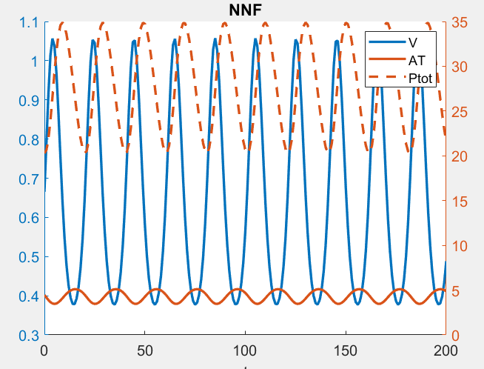

expands a little bit

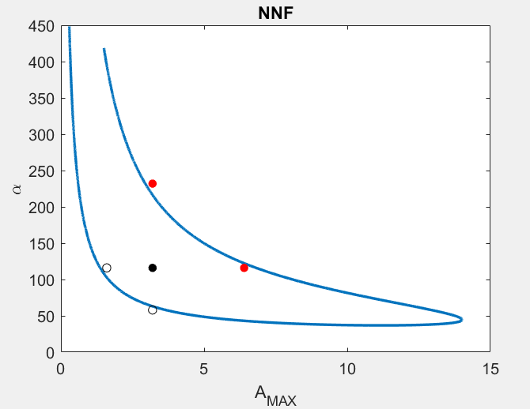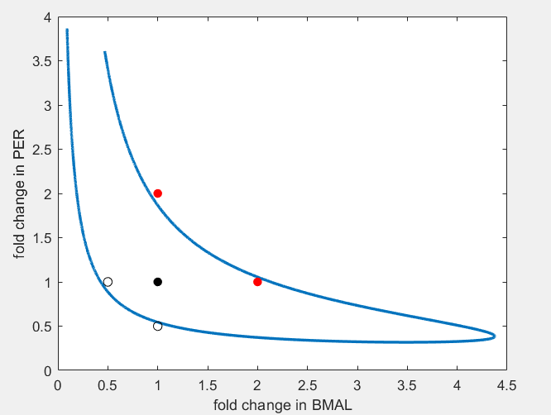

max(Ptot) ~35

5-point barely met with AMAX=3.2, alpha=116

Parameter sets from seemingly another domain

3) delta = 3.2, Amax =18, Vmax = 3.8, Ka=16, alpha= 47, Km= 1, beta= 4

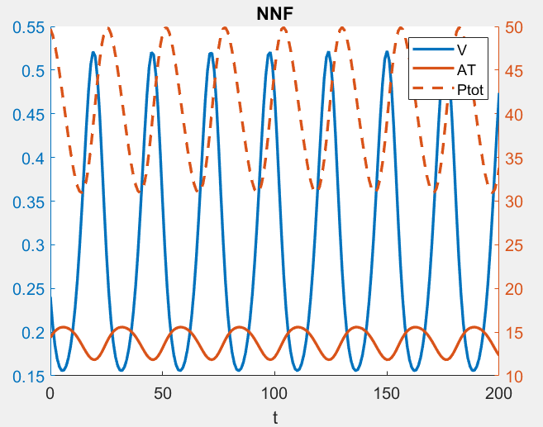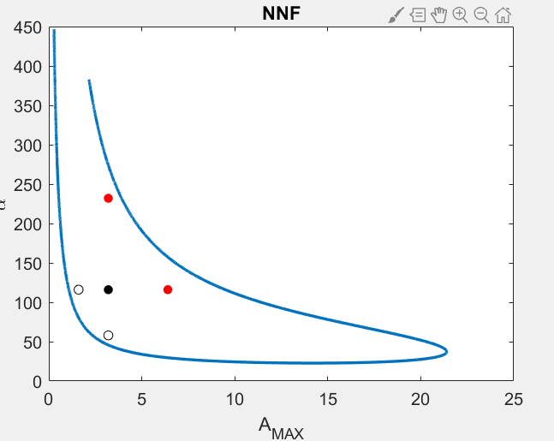

5-point met with Amax=3.2, alpha=116

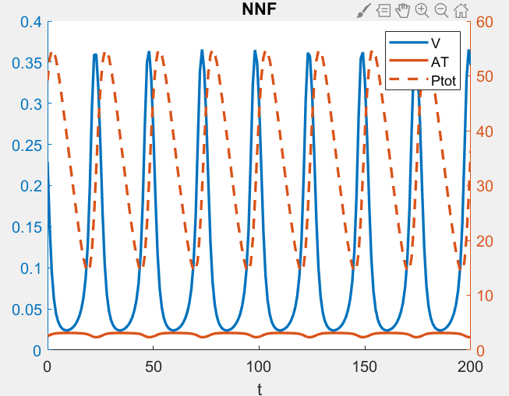 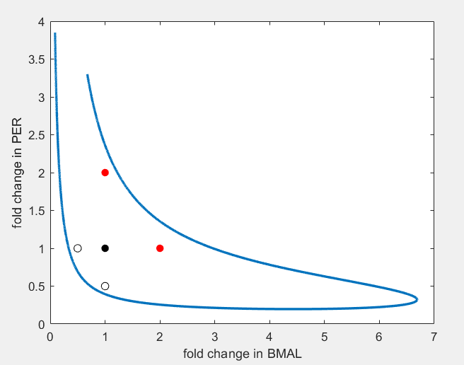

max(Ptot) ~55

4) delta = 4.6, Amax =14, Vmax = 0.7, Ka=16, alpha= 17, Km= 1, beta= 3.5

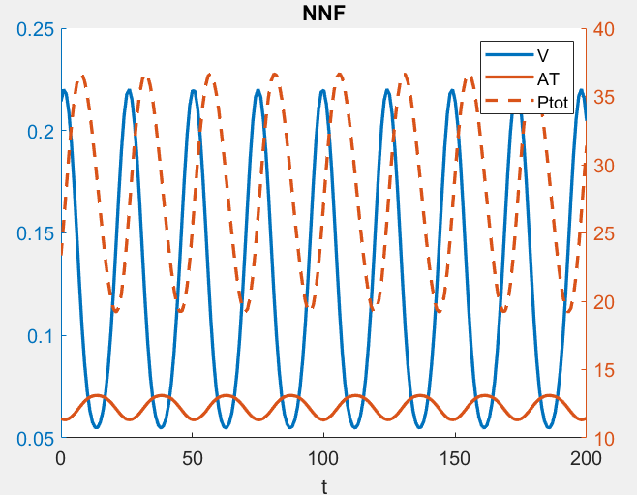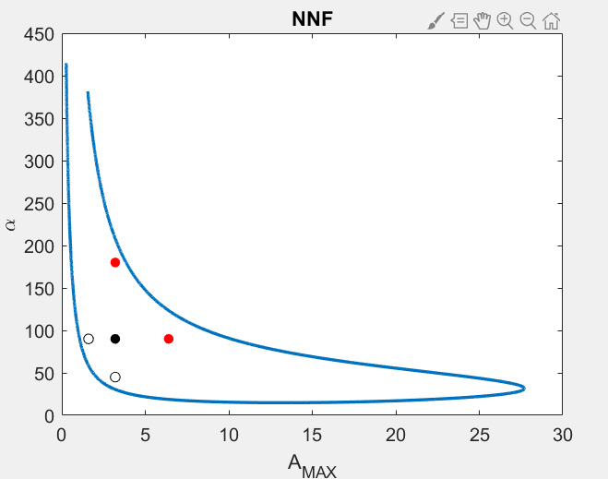

5-point met with Amax=3.2, alpha=90

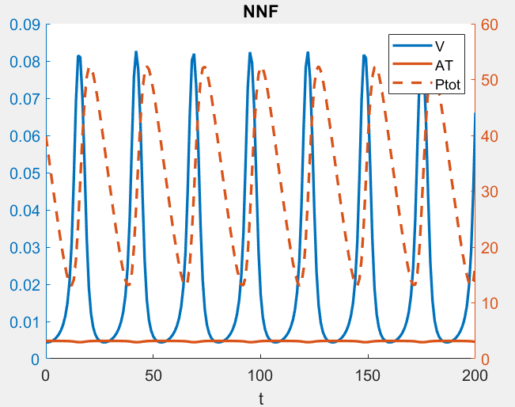

max(Ptot) ~55

3. PNF